CHAIRMAN
GRAHAM BROOKES
OLD LONDON HOUSE
MAIN ROAD
KNOCKHOLT
TN14 7JE
01959 533772

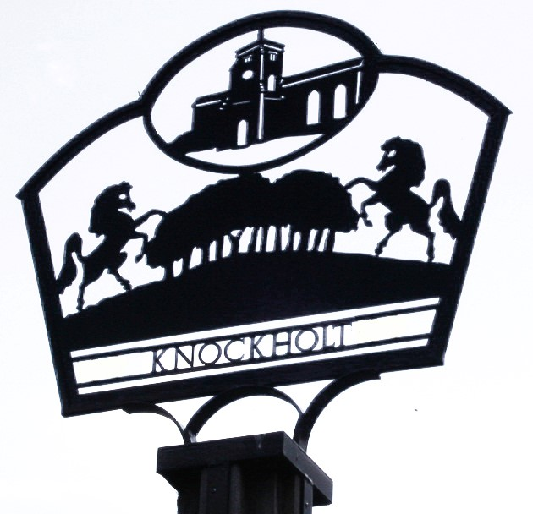

ANNUAL PARISH MEETING

MONDAY 14th April 2025 –7.30pm
Knockholt Village Centre

AGENDA

- Apologies for absence.
- Chairman’s Annual Report, Graham Brookes.
- Report on financial accounts, Zoe Brookman, Responsible Financial Officer.
- Questions from Parishioners.
- District Councillor for Halstead, Knockholt and Badgers Mount, Gary Williamson.

